
Year 10

Mini Test 4 Pathway 1

Linear Equations, Quadratics and Polynomials

Resources allowed: Calculator and 1 x A4 page one side

Name: ______________________ Class: ______ Time: 60 minutes Total Marks: ____/61
Show working and answers on this sheet. Show working in sufficient detail to support your answers. Incorrect answers without supporting reasoning may be allocated zero marks.

Circle the correct answer.
[6 marks: 1, 1, 1, 1, 1, 1]
1. | What is the leading term of the polynomial  12x2 + 4x3 + x7 − 3x − 9x4 − 1?  A 12x2 B x7  C 4x3 D −9x4 | 2. | What number should be added to both sides of the equation x2 − 8x = 20 to complete the square?  A −8 B 82  C −4 D 42
3. | What is the degree of the polynomial  2x2 + 4x3 + x7 − 3x − 9x4 − 1?  A 2 B 6  C 7 D 9 | 4. | What are the values of a, b and c when solving  x2 − 3x − 5 by the formula?  A a = 0, b = 3, c = 5  B a = 1, b = 3, c = 5  C a = 1, b = −3, c = −5  D a = −3, b = 1, c = −5
5. | Which of the following are factors of the polynomial x3 − 3x2 + 5x − 6?  A (x − 1) B (x − 2)  C (x + 1) D (x + 2) | 6. | A trinomial is a polynomial with three terms.  A True B False

Solve the following problems:
[11 Marks: 1, 1, 1, 2, 3, 3]
7 | $$x+4=7$$ | 8. | $$5x+3=23$$
9. | $$\frac{x+1}{2}=9$$ | 10. | $$-2(f+5)=10$$
11. |  | 12. | $$\frac{2x}{3}+3=\frac{x}{2}$$
Solve the following quadratics by factoring:
[6 Marks: 3, 3]
13. | $$x^{2}+6x+8=0$$ | 14. | $$x^{2}-10x+25=0$$
Solve the following quadratics by completing the square:
[6 Marks: 3, 3]
15. | u2 + 10u − 9 = 0 | 16. | $$x^{2}+6x+2=0$$

Solve the following quadratics using the quadratic formula:
[6 Marks: 3, 3]
17. | 8$r^{2}+6r-15=0$ | 18. | $${36n}^{2}-12n+1=0$$

19. [4 marks: 2, 2]
Q(x) = 7x³ – 9x + 4. Find:
(i) Q(2) (ii) Q(-2)

Simplify the following:
[6 Marks: 1, 1, 2, 2]
20. | (2x² – 4x + 2) + (7x² + x – 7) | 21. | (8x² + 2x + 10) - (4x² - 5x + 3)
22. | (x + 3)(x² + 7x +11) | 23. | (x² – 2x + 1)(x² + 5x + 6)
Solve the following:
[7 Marks: 2, 2, 3]
24. | (x² -7x – 11) ÷ (x – 8) | 25. | 3x3 + 7x2 − x + 10 is divided by x + 3.
26. | (x³ - 30x – 18 – 4x²) ÷ ( x + 3)

27. [3 marks]
Is x – 2 a factor of x² + 2x – 8?

28. [3 marks]
Solve x³ – 2x² – x + 2 = 0

29. [3 marks]
This rectangle has an area of 120 cm². What is its length?
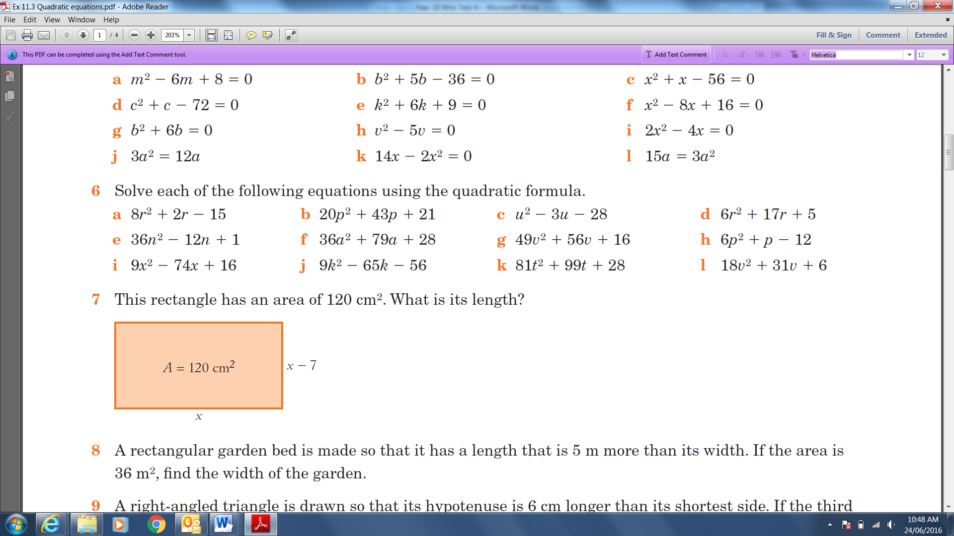

End Test

